**SPRINT GOAL:** End up with four new windows, the main of which are the Database View and Add Item view. Here, the user story is completed: An admin can add an item to the database. (EXTRA: HE CAN SEE IT)

The sprint goal was achieved.

| PB-ID | ID | Task Title | Responsible | Estimate (hours) | Status |
| --- | --- | --- | --- | --- | --- |
| 2 | 1 | Design & Create Start view | Robert | 4 | Completed |
| 2 | 2 | Design & Create Login View | Robert | 4 | Completed |
| 2 | 3 | Design & Create Database View | Daniel + Laura | 4 (2*2) | Completed |
|  | 4 | Design & Create Add Item View | Laura + Kamil | 4 (2*2) | Completed |
| 2 | 5 | Implement View Controller & VM for Start View | Robert | 4 | Completed |
| 2 | 6 | Implement View Controller & VM for Login View | Robert | 4 | Completed |
| 2 | 7 | Implement View Controller & VM for Database View | Daniel + Laura | 8 (4*2) | Completed |
| 2 | 8 | Implement View Controller & VM for Add Item View | Kamil | 8 | Completed |
| 2 | 9 | Implement Item DAO | Laura + Kamil | 16 (8*2) | Completed |
| 2 | 10 | Add Item methods to the Database Manager | Laura + Kamil | 2(1*2) | Completed |
| 2 | 11 | Document Views - what, why, how (sprint-oriented) | Robert | 4 | Completed |
| 2 | 12 | Document MVVM - view controllers, viewmodels (implementation-oriented) - INCLUDES TESTING | Kamil + Robert | 16(8*2) | Completed |
| 2 | 13 | Document ITEM DAO & new database manager | Kamil + Laura | 8 (4*2) | Completed |
| 2 | 14 | Test & Document testing of ITEM DAO | Laura + Kamil | 8(4*2) | Completed |
| 2 | 15 | Document Database View & ViewModel | Laura | 2 | Completed |

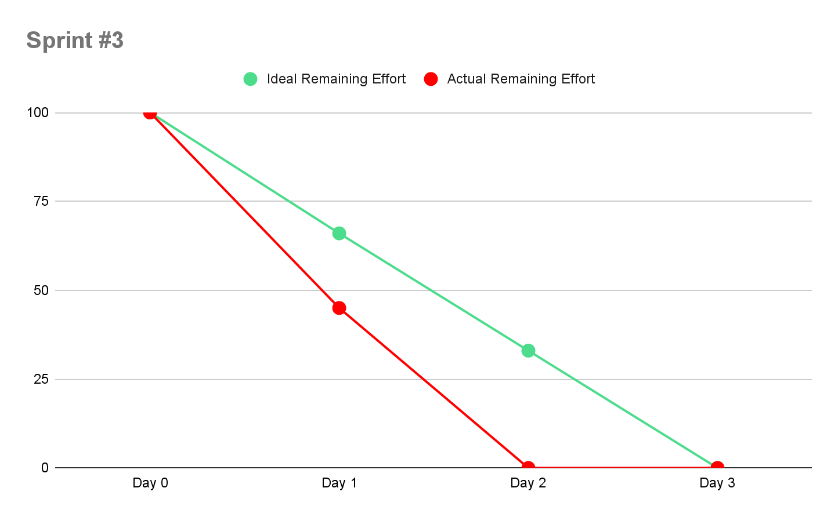

**WHAT WAS ACHIEVED:**

* Everything in the sprint backlog. Four new working windows. A database view which fetches from the database.

**WHAT WENT WELL:**

* Kamil learned DAO:), Laura made her first window, Robert two too, Daniel learned some Scenebuilder, Documentation is going smoother & smoother

**WHAT TO DO NEXT:**

* NEXT PRODUCT BACKLOG ITEMS:
  + ADMIN: Remove item (reduce estimate. it’s easy)
  + CUSTOMER: See every item (Customer view Rework)